James Carlisle Beaver III

January 6, 1949 – November 30, 2024

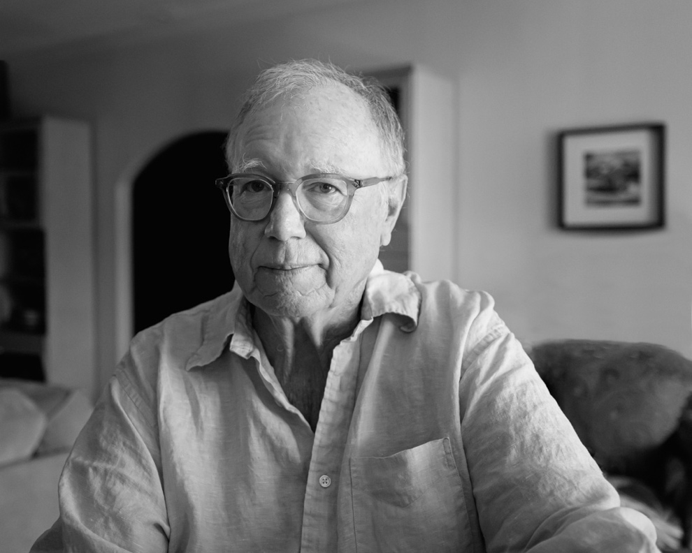

Jim Beaver, a longtime journalist and public health advocate in West Contra Costa County, died from cardiac arrest Nov. 30, 2024, in Palm Desert. He was 75.

Born James Carlisle Beaver III Jan. 6, 1949, in Los Angeles, Jim grew up in LA’s Manhattan Beach and Studio City neighborhoods. As a kid he would ride his bike to Dodger Stadium to watch his beloved men in blue play. A passionate lifelong Dodgers fan, he reveled in the team’s 2024 World Series championship in October.

Beaver graduated high school from St. Augustine in San Diego. In his 20s, he worked for the Pacific Bell telephone company in downtown San Francisco, and then studied nursing at College of Marin. He met Jane Wiester in 1979 at French Hospital in San Francisco where he worked as a pharmacy tech. They were married in 1980.

Beaver’s real career ambition, however, was to be a newspaper reporter. After studying journalism at San Francisco State University 1979 to 1982, where he was editor of the campus newspaper, Beaver landed in West Contra Costa County where he started as a freelancer for the *Richmond Independent* before being hired at the *West County Times*.

Beaver covered the often rough-and-tumble politics and city government of Richmond from a storefront satellite bureau near City Hall. He earned the respect and admiration of officials he covered for his fairness, even when they were unnerved by his knack for quickly getting to the nub of a thorny or complex issue, or exposing backroom shenanigans hidden from public view.

His colleagues remember him fondly as a team player and calm, steady presence in the chaos of the newsroom as well as for his dry wit. Also, as a reporter who set the bar high with the quality and quantity of his work. A newspaperman’s newspaperman, Beaver wrote a popular Herb Caen-style column for the *West County Times*.

In 1989, Beaver left the *West County Times* to become public affairs director at Brookside Hospital in San Pablo, the only public medical center serving a region with a large low-income population. In the increasingly hostile environment for public hospitals of the 1990s, Brookside faced closure in 1997. Beaver spearheaded the effort to save the hospital and became executive director of the West Contra Costa Health District.

He devised and oversaw plans for the district’s successful acquisition of the Brookside medical center in 2004 from Tenet Healthcare Corp. which managed Brookside and a hospital in Pinole under the name Doctors Medical Center. This included managing the campaign for the 2004 Measure D, the parcel tax to help fund the hospital that received the highest approval for a parcel tax initiative in California history. Beaver subsequently was elected to the West Contra Costa Healthcare District/Doctors Medical Center San Pablo Board of Directors. For his “dedicated and valued service to improve the healthcare of the people of West Contra Costa County,” the Contra Costa County Board of Supervisors proclaimed Nov. 19, 2004 “Jim Beaver Day.”

Civic engagement was integral to Beaver’s success both as a journalist and community leader. He was active in the Richmond Rotary Club and served as its president from 1996-97.

Beaver and his wife Jane moved to Palm Desert in 2008, where Jim continued to work in the healthcare field, notably as a partner in his wife’s healthcare consulting firm but also advising and speechwriting on healthcare public policy issues.

Beaver had broad interest in the cultural arts, especially music, from The Kinks, The Beatles and ‘Stones to Willie Nelson to a variety of jazz and classical music. He loved sports, from boxing matches at the Richmond Municipal Auditorium to the Dodgers. A former newspaper colleague recalled receiving a letter from Beaver describing his infant son listening to his first-ever broadcast by legendary Dodgers announcer Vin Scully. Beaver was a fine cook with a reputation on the East Bay chili cookoff circuit for making both the competition and judges sweat with his prize-winning recipes.

But Beaver never lost his love of journalism. When he died, he was subscribed to five magazines, three daily newspapers and the Sunday *New York Times*.

Beaver was preceded in death by his brother, William Barclay Beaver. He is survived by his wife, Jane Wiester Beaver of Palm Desert; son, Christopher Beaver of Gladstone (Claire Bukata), New Jersey; sister, Kathleen Beaver of Palm Desert (Don Nowak); and brothers, Daniel Beaver of Oakland (Deborah Panter), and Timothy Beaver of Los Angeles (Pam Tsakirgis).

Beaver also will be missed by many admiring friends and former colleagues. His son Christopher Beaver summed it up best: “He was smart, he was witty, he was kind, he was curious, and he was cool.”

Donations in Jim Beaver’s memory may be made to the American Heart Association: <https://www.heart.org/en/affiliates/california/northern-california>